 

Project Title: Lease Management

College Name: **MAILAM ENGINEERING COLLEGE**

Code: **4216**

## Department of Computer Science and Engineering

**Team Leader:**

Name: ANITHA P Reg No: 421622104006

## Team Members:

Name: ANITHA V Reg No: 421622104007

Name: MAHALAKSHMI K Reg No: 421622104076

Name: VANAJA S Reg No: 421622104149

Registered Email Id: [eprabhakaran59@gmail.com](mailto:eprabhakaran59@gmail.com)

TrailheadUrl:

<https://www.salesforce.com/trailblazer/pcnqrky6sv3unxl58s>

 

# Project Name: Lease Management

### Project overview:

This project is based on Lease Management System, which, in a strategic alliance with Salesforce.com, develops an application for managing properties. LMS is an application that incorporates all the functions necessary to manage different processes of the real estate sector with the best practices in mind.

It is delivered as a service (SaaS) and accessed via Internet from any device. Salesforce.com (www.salesforce.com) provides the technological platform that supports the data storage, the security elements and protocols. This study

aimed to design and develop a cloud-based Lease management system that provides detailed and summarized information on these critical areas to guideLMS administrators in planning and decision-making. It is accessible anywhereanytime as data is stored remotely and made available to users over the

internet.

This project is user-friendly, usable, performance, and security; and good in terms of robustness. This implies that other owners may adopt this system for more efficient information management and more effective management decisions and to maintain good relationships with Clients LMS allows the management of real estate businesses.

### Objective:

The main objective of a leave management system is to help businesses manage employee absences in a fair and accurate way. This can be achieved by:

 

#### Business goal:

Leasing assets is a common practice for companies of all sizes and industries. Among their many advantages, leases increase businesses' purchasing power, decrease maintenance costs (if the lessee isn't responsiblefor maintenance) and help better manage cash flow.

#### Specific outcome:

Leasing assets is a common practice for companies of all sizes and industries.

Among their many advantages, leases increase businesses' purchasingpower, decrease maintenance costs (if the lessee isn't responsible for

maintenance) and help better manage cash flow.

#### Streamlining the leave process

A leave management system acts as a channel between employees and employers to make the leave application and approval process more efficient.

#### Providing visibility and control

Employees should be able to easily apply for leave, view their leave information, and track the status of their leave requests.

#### Eliminating paperwork

Leave management systems automate the leave request process, reducing the need for manual intervention and paperwork.

#### Complying with statutory requirements

A leave management system should be able to comply with the statutory requirements of the state.

 

**Salesforce Key Features and Concepts Utilized**

### Organizing:

Creating a sales plan and assigning responsibilities to team members

### Sales strategy:

Building and implementing strategies that are easy to understand and execute.

### Customer relationship management:

Maintaining meaningful relationships with key customers

### Sales analytics:

Analyzing data from past campaigns to create better and more optimized campaigns.

### Coaching:

Helping sales representatives improve their performance and reach their true potential.

### Forecasting:

Planning for the road ahead to ensure proper inventory and staff levels, and to plan for compensation.

 

# Detailed steps to solution design

### Step 1: Creating Developer Account and Activation

Creating a developer org in salesforce.

To Activate the account, click on the verify account. Give a password and answer a security question and click on change password.

Give a password and answer a security question and click on change password. Then you will redirect to your salesforce setup page.

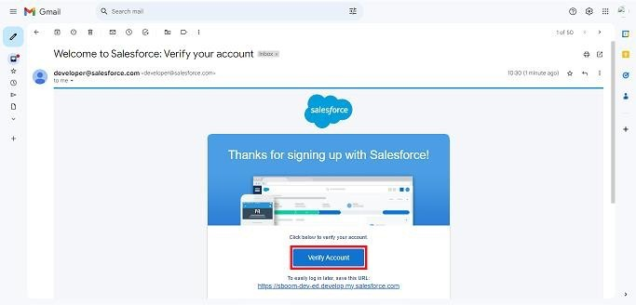

 

### Step 2: Create of objects

Create Property Object, tenant object, lease object andpayment

object.

From the setup page >> Click on Object Manager >>Click on

Create >> Click on Custom Object

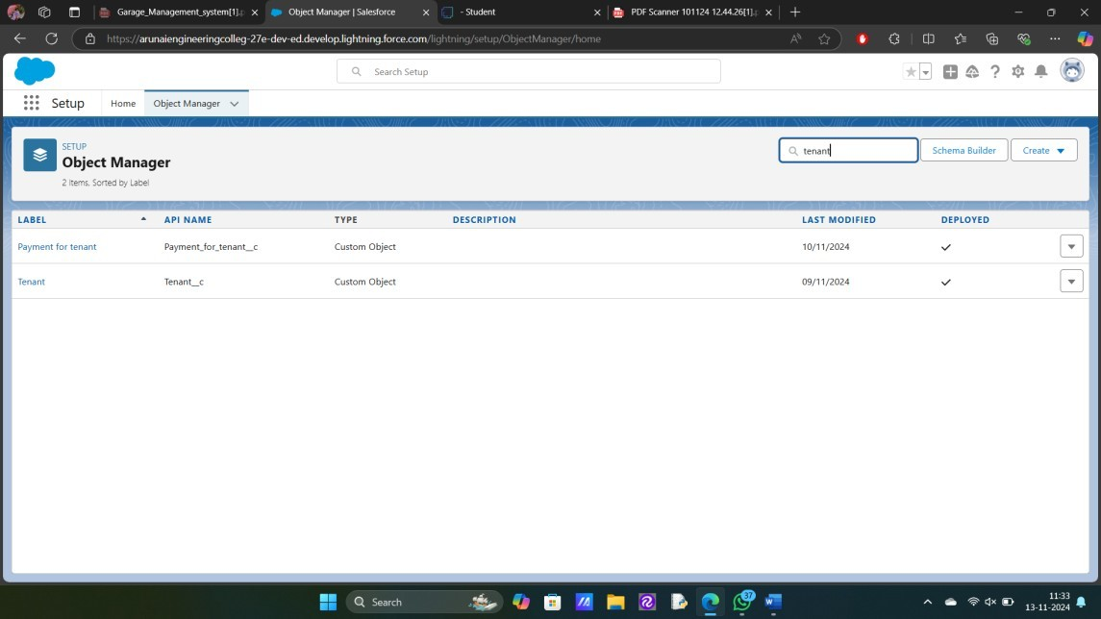

Enter the label name for the appropriate object. Then enter thePlural label name.

Enter Record Name Label and Format Record Name and Data Type.

### Step 3: Creating a Custom Tab

A tab is like a user interface that is used to build records forobjects and to view the records in the objects.

 

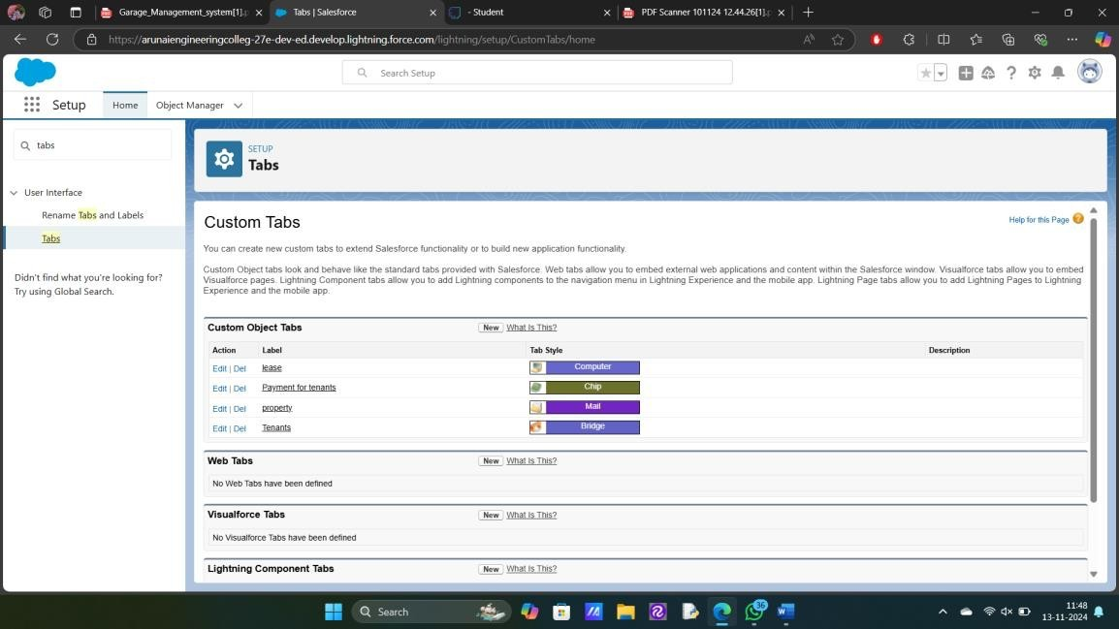

### Step 4: Create a Lightning App

An app is a collection of items that work together to serve a particular function.

### To create a Tab:( Property)

* Goto set up page. Search tabs on quick find bar click new under custom tab.
* The first step is to select object property and tab style.
* Make sure that the Append tab to users' existing personal customizations is checked. Click save

 

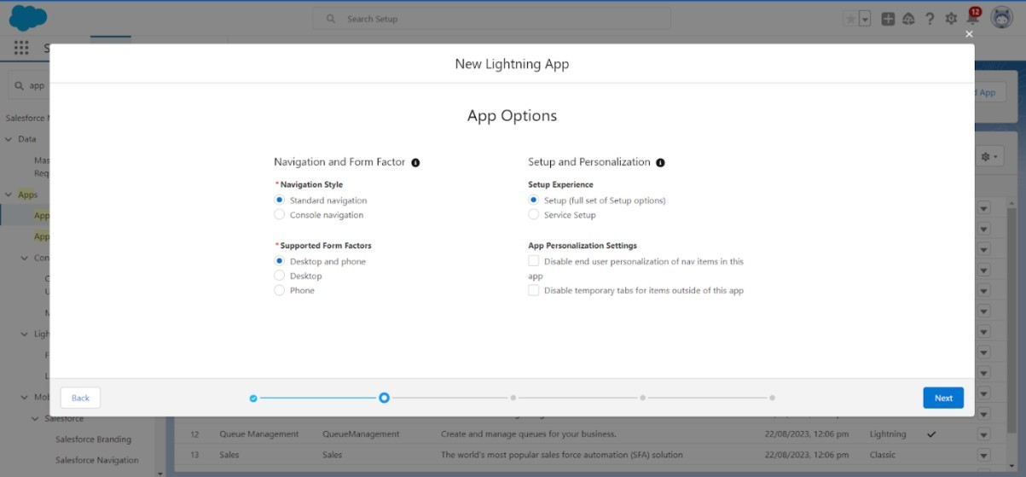

Create a lightning app with an App Name of “Lease Management”

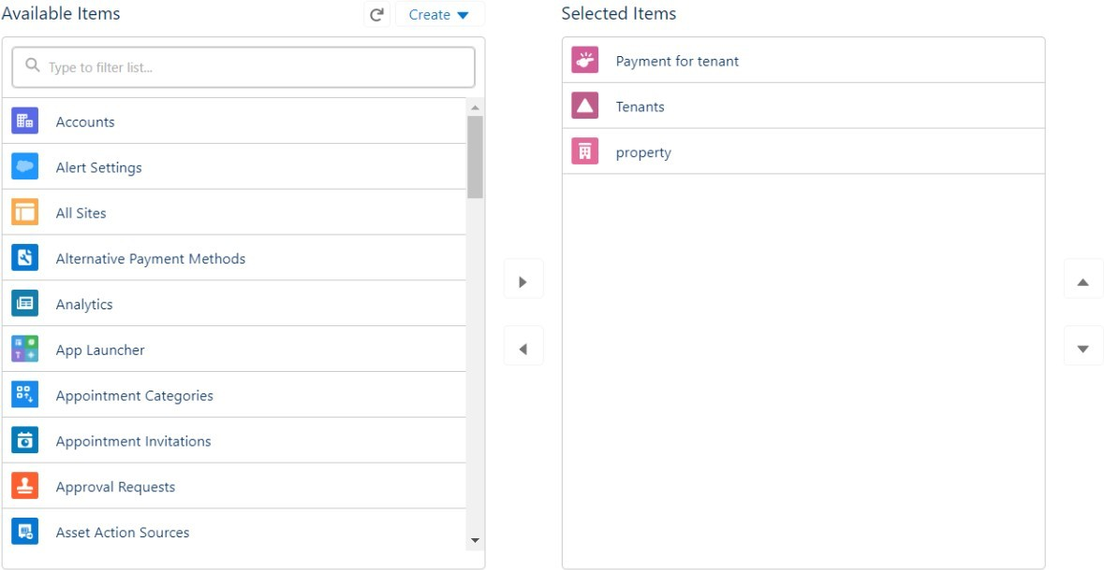

### Step 5: Field Creation

Creation of fields for the property object, Tenant object, Lease object, Payment for tenant object, Lookup object.

 

Go to setup then click on Object Manager to type object name(Tenant) insearch bar and click on the object.

* Field Label : Email
* Field Name : gets auto generated
* Click on required check box
* Click on Next >> Next >> Save and new.
* Field Label : start date
* Field Name : gets auto generated
* Click on Next >> Next >> Save and new.

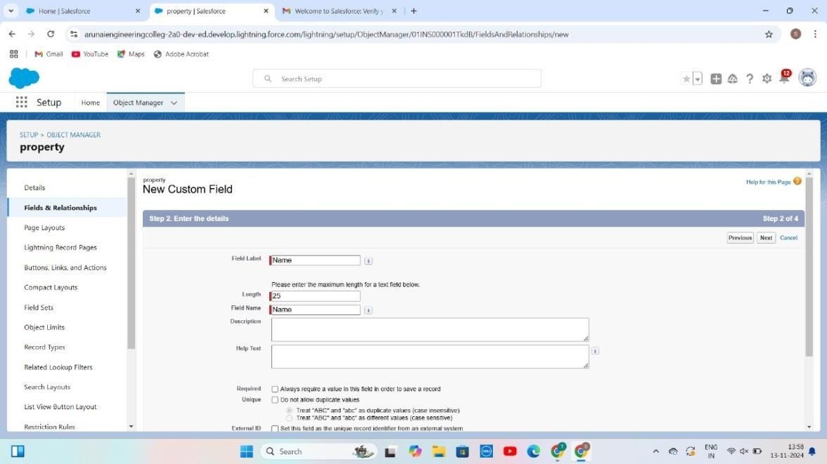

 

### Step 6: Validation rules

To create a validation rule to an Lease Object.

Go to the setup page click on object manager from drop down click editfor Lease object**.**

Click on the validation rule.click new Rule name= lease_end_date

* + Insert the Error Condition Formula as : End_date c > start_date c

Enter the Error Message as “Your End date must be greater than start date”, select the Error location as Field and select the field as “start date”, and click Save.

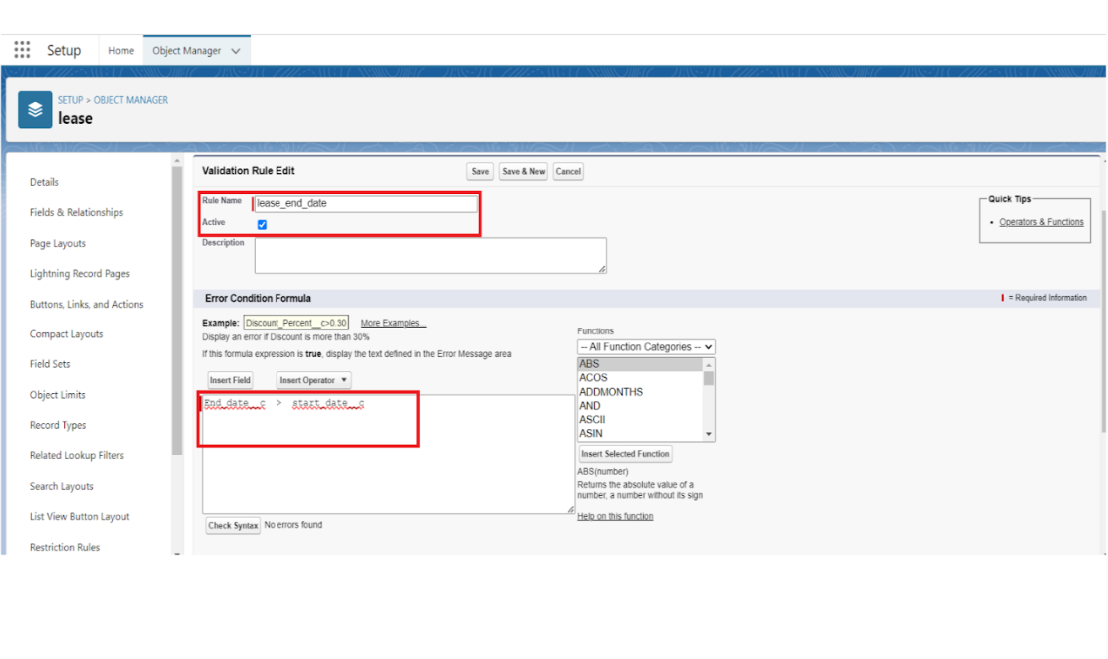

 

**Step 7: Email templates**

### Create Email Template For Tenant Leaving

* + Go to setup in quick find box enter email template, click on classic Email template.
  + Then click on new email template choose text
  + Email template name: tenant leaving
  + Template unique name: Auto populated
  + Subject: request for approve the leave
  + Email body:

Dear {!Tenant

c.CreatedBy}

,Please approve my leave.

* + Save.

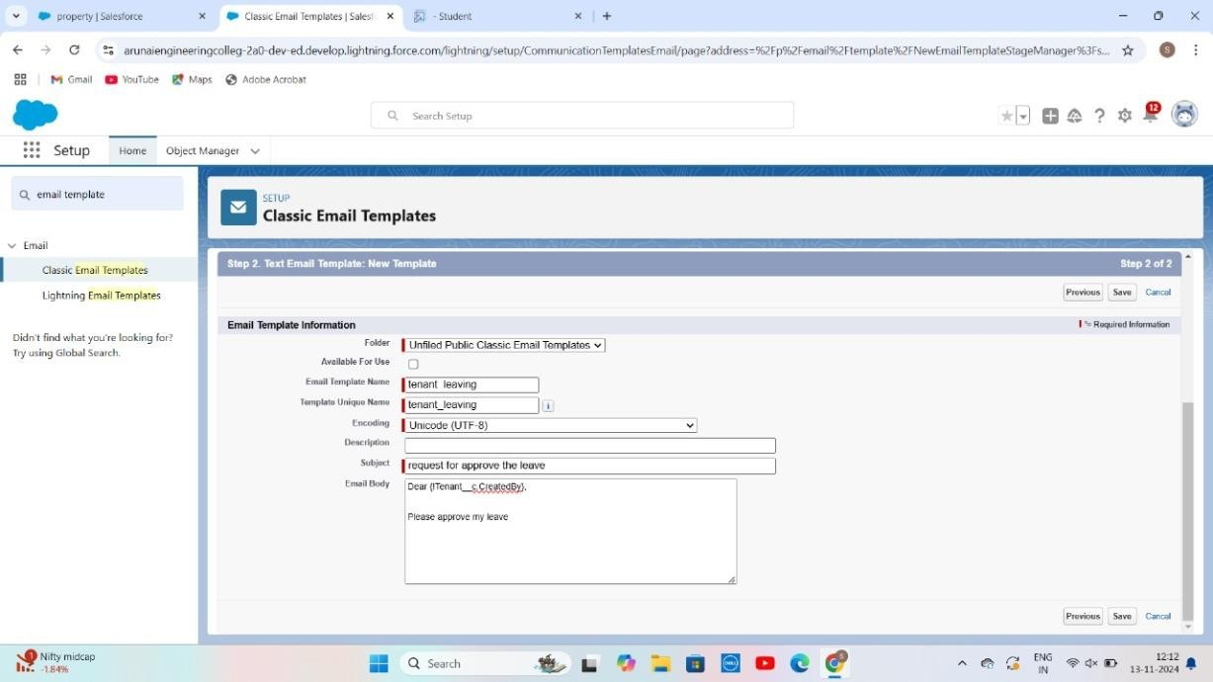

 

### Create Email Template For Leave Approved

* + Go to setup in quick find box enter email template >> click on classic Email Template.
  + Click on >> New Email Template===>Choose text
  + Email Template Name=Leave approved
  + Template Unique Name : Auto populated
  + Subject =Leave approved
  + Email body :
  + dear{!Tenant c.Name},

I hope this message finds you well. I am writing to inform you that I have received your email confirming the approval of my leave request.I would like to express my gratitude for considering and approving my time off.

Your leave is approved. You can leave now.

* + Save

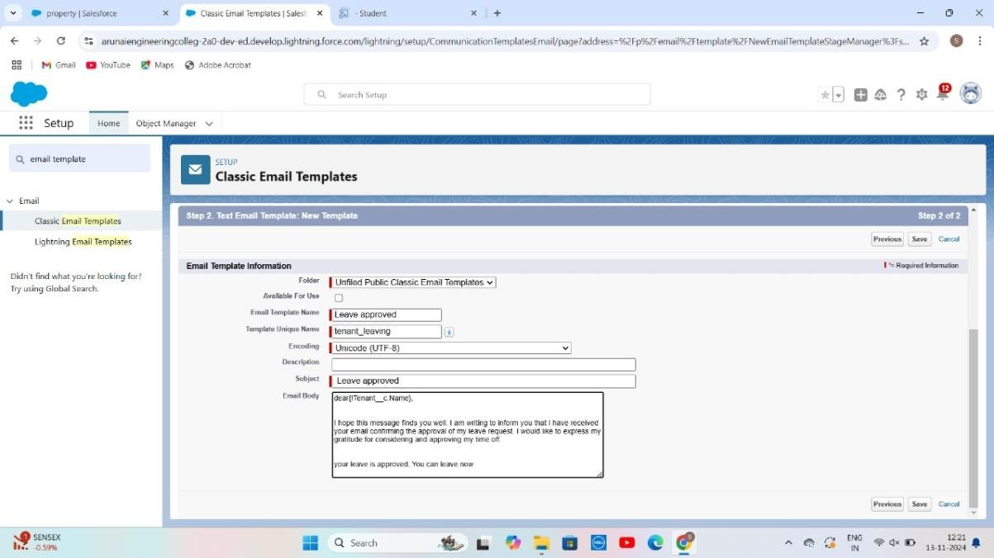

 

### Create Email Template For rejection for leave

* + Go to setup in quick find box enter email template >> click on classicEmail Template.
  + Click on >>New Email Template===>Choose text
  + Email Template Name=Leave rejected
  + Subject : ” Leave rejected”
  + Email body :
  + Dear {!Tenant c.Name},
  + I hope this email finds you well. Your contract has not ended. So we can't approve your leave
  + your leave has rejected
  + Saved

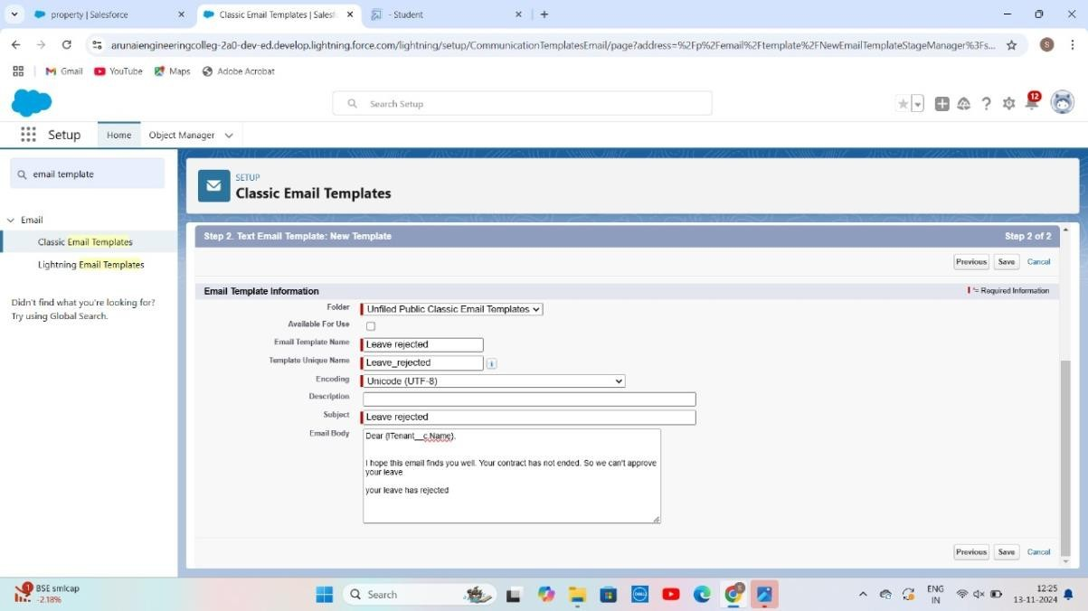

 

## Step 8:Approval Process

### What Is Approval Process In Salesforce?

The Approval Process is an automated process that an org uses to approve records in Salesforce. For example, When In the organization, someone is not able to decide a particular thing then he can ask someone else for

approval. So, for such frequent cases or situations, one can define the approval process. So, Users can take benefit of such an approval process whenever needed.

There are 4 actions,

1. Initial Submission Actions
2. Final Approval Actions
3. Final Rejection Actions
4. Recall Actions.

An approval process consists of finalizing the basic properties of the approval process (as shown in the below image), approval steps, and actions to be executed.

### Create Approval Process For check for vacant.

* + Go to setup >> Approval Processes in quick find bar>>click on it.
  + Manage Approval Process For >> “Tenant” from the drop down.
  + Click on “Create New Approval Process” >> Use standard setupwizard
  + Process Name “check for vacant” >> Click Next.
  + Field “Tenant:status” >> Operator : Not equals , Value >> Click on thelookup filter icon and select “Leaving”.
  + 6.Click insert field,then click Next.

 

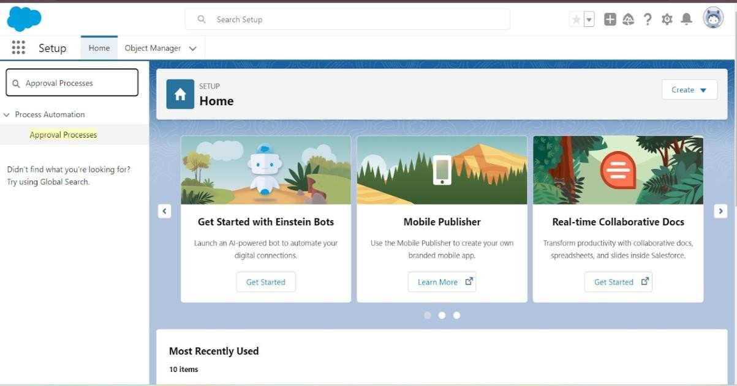

* Next Automated Approver determined by “None” from the drop down.
* Select the “Administrators ONLY can edit records during theapproval process”. Then Next.

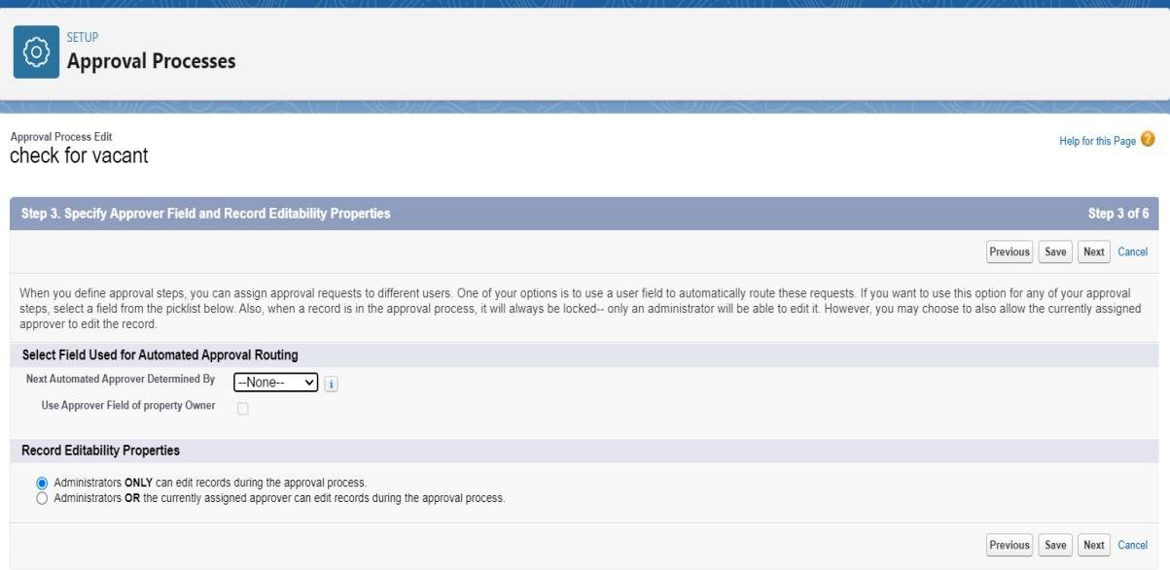

 

* Click on next leave the email template click on next
* Submitter type Search>>Owner, Allowed Submitters>>Property Owner. Then Next.
* Then click on Save.

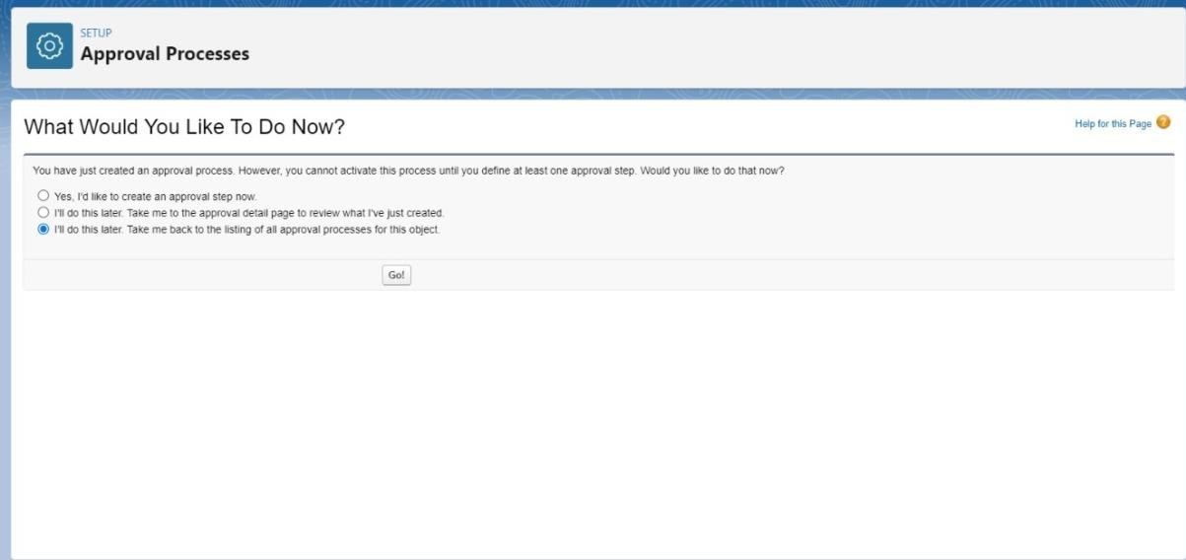

* Click on “i’ll do this later. Take me back to the listing of all approvalprocess for this object”
* Click go.

### Initial Submission Action:

* + Under initial submission action click on add new and then select email alert.
  + Description: “please approve my leave”.
  + Unique name: auto populated.
  + Email template: tenant leaving.
  + Recipient type: Email field.

 

## Step 8: Flows

In Salesforce, a flow is a tool that automates complex business processes. Simply put, it collects data and then does something with that data. Flow Builder is the declarative interface used to build individual flows.

**Create Flow for monthly payment**

1. Go to setup then type Flow in quick find box Click on the Flowand Select the New Flow.
2. Select the record Triggered flow. Click on create.

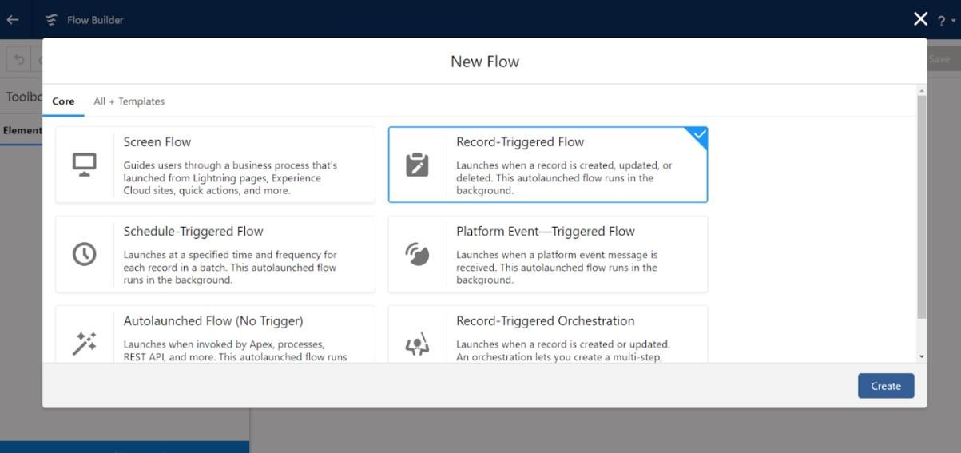

Click on: Every time a record is updated and meets the condition requirements Click on: Actions and related records is done

 

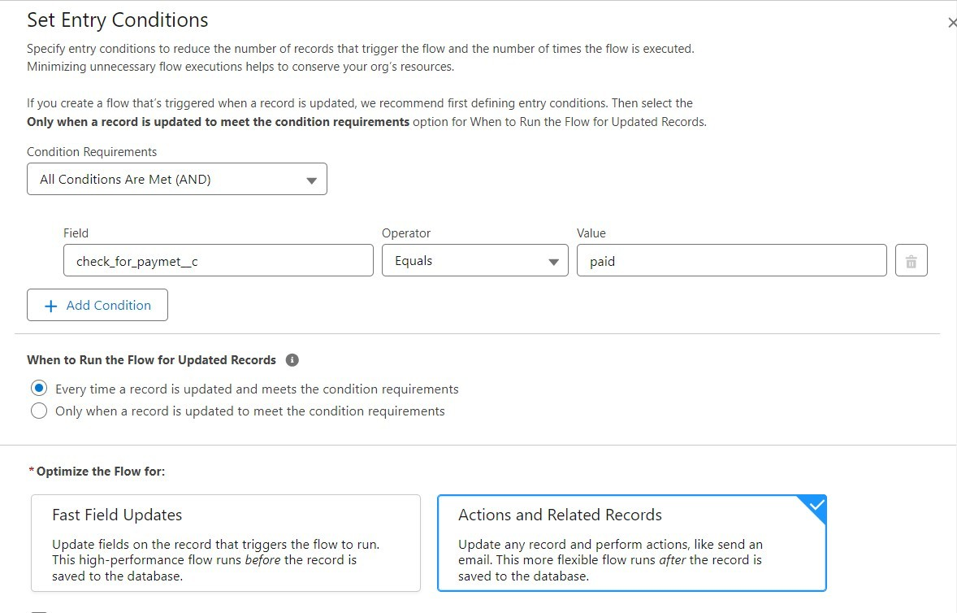

## Test and validation:

Testing and validation in lease management can involve a variety of activities, including:

**Lease validation services:**

Help property management companies ensure that lease agreements are legal and enforceable. These services can help identify issues and verify the terms and conditions of a lease.

### Test planning and execution:

This involves executing and monitoring validation tests according to a test plan and design. It also includes verifying and validating the test results, and recording and reporting any issues or defects.

 

### Test objectives and criteria:

These should be defined clearly and explicitly before starting testing and validation. They should align with the project's goals, scope, specifications, and the needs and expectations of the stakeholders and users.

### Validation testing:

This is used to verify that the final product meets the expectations and requirements of the customers and stakeholders. It usually happens after the product is fully developed and focuses on confirming that it works as intended in real-world scenarios.

# conclusion:

Lease financing is the best option for those who cannot raise the fund with debt financing, assets can lease their assets to the companies those who required such assets.

Thus, leasing become constructive for both the parties the lessor and the lease also using our lease management system which is CRM based application an can find a customer and anyone can find a good place for the business or for residential purpose. our project is useful for both residential people as well as a business person.